Your group leader will be choosing where you start your visit and the order in which you cover different areas of the Castle and the Museum. You will need to stay together as a group, be observant and make clear notes and sketches.
Name: __________________

History Group: __________
History | Stansted Mountfitchet Castle Activity Sheet

THE CASTLE
- The Approaches to the Castle

- What are your first impressions of the castle near the siege tower? If you were planning an attack, what are some of the problems that you would have to overcome? Dry moat (with pointed stakes, also moat soaked in oil and set on fire to stop an invading army). Steep Hill, Palisade and Towers. (Answers for this on Green sign)

- Study the remaining section of the 12th Century wall. Why do you think there is only this section left? What may have happened to the rest? When the stone castle was destroyed the locals from the village salvaged the stones etc to build their houses.

- Study the recreated siege tower and battering ram.
Why might it have been difficult to use this in attacking Mountfitchet Castle?
- The moat would have made it difficult to get across to the castle
- Steep Hill

- Draw an outline field sketch of the approaches to the castle and the main gate from near the Visitor Centre. Use labels to record different features, materials used etc.

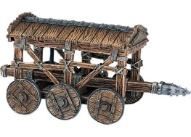

- The Main Gate and Charcoal Burners

- Find the mine entrance; what was the purpose of this?
Enemy miners dug tunnels under the castle walls and into the main castle and built a chamber or room under a strategic point and filled it with brushwood and animal fat and then set it alight to collapse that area to weaken the castle’s defences and to make an attack easier.

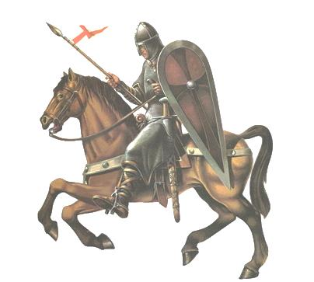
- How was charcoal used and why was it important?

It was used in the Smithy or Blacksmiths for iron smelting because charcoal gives off twice as much heat as wood.

- What was the value to the people of an Eel Pond?
Food to enrich their diet.

- What story does the ‘plague stone’ tell us about medieval life?
The Plague stone was used to kill the germs off money, this shows how unsanitary, dirty and disease ridden medieval life was.

- Why might the main gate have been a tough place to attack and capture?

It was tall so defending archers could shoot attackers from it and solid making it difficult for attackers to break through it.

- The Village [In the Bailey by the Gate]

- Find The Stores, what did the Normans do to avoid waste from animals (Green sign).
Bones were used for tools, sheep bladders were made into drinking vessels and hides were used for rugs and clothes.

- The Prison; what were some of the punishments that were used and for what crimes?
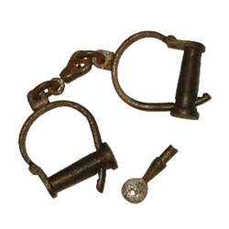
Hand cut off, blinded or hung for hunting deer.

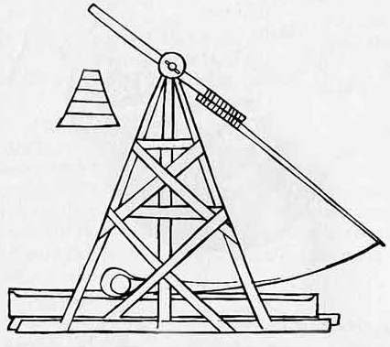
- Have a look at the recreated catapults, what did the Normans call them in the medieval time?
Perrier.
Mangonel.
Trebuchet.

- The Kitchen; what can you recognise here that you find in your own home and what is very different? Lots of different answers here e.g. pots are the same but no electrical items so a fire oven instead of an electric oven.

- Weaver’s House; briefly describe how wool was turned to cloth. Spun on a spindle, dyed and threads were woven into cloth

- The Surgeon’s House; why might having to amputate a limb have been very common and why do you think it was done so quickly?
Lack of antiseptic/lack of medicines
It was completed in less than a minute, normally about 20 seconds, to stop blood loss.

- The Village [Far Side of the Bailey]

- What was the Hell-Hole used for?
Putting prisoners and captured soldiers in to be left to die.

- The Potter’s Hut; why was what the Potter produced so useful?
The Potter produced all the jugs and pots etc. for the castle which people needed for everything.

- The Brewer’s Hut; why was beer and wine so important to people then?
It was safer than drinking dirty water from the river or a well.

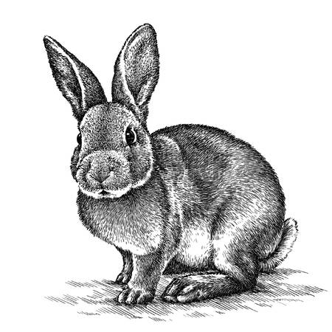
- The Ducking Stool, what was it used for? Torturing women by ducking them under water and to find out if a suspect was a witch.
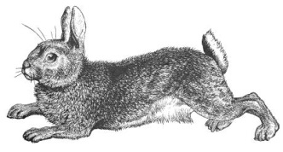
- The Blacksmith; what was made and repaired here?
Lots of options e.g. swords, daggers, tools, protective armour.

- The Church; how do we know that this was one of the most important parts of any village?
The Priest was the only literate member of the castle community and people were very religious so the Church was very important.

- Choose at least one other aspect of the village and sketch or describe it, making sure you include how / why it was important.

Lots of options here.

- The Inner Bailey and Grand Hall

- Why would the inner Bailey have been a tough place to attack?
The inner Bailey was protected by a Barbican entrance which was two large walls creating a narrow passageway making the attacking army an easy target. Also because the outer Bailey had to be breached first before reaching the entrance to the inner Bailey.

- What do you think the Grand Hall was used for apart from feasting?
- Hall of Justice
- Council Chambers to discuss important matters concerning the castle

- The Armoury, list some of the weapons you can see and explain which you think would have been the most deadly.
Lots of options here.

- Upstairs is the Baron’s Bedroom, how does this compare to other parts of the castle you have seen?
Looks very comfy, rich and warm compared to the rest of the castle e.g. stained glass window, animal fur blanket, bed, paintings decorating the walls.

- Choose one other aspect of the Inner Bailey to describe and explain. Sketch it if possible.
Lots of options available

