Your group leader will be choosing where you start your visit and the order in which you cover different areas of the Castle and the Museum. You will need to stay together as a group, be observant and make clear notes and sketches.
Name: __________________

History Group: __________
History | Stansted Mountfitchet Castle Activity Sheet

THE CASTLE
- The Approaches to the Castle

- What are your first impressions of the castle near the siege tower? If you were planning an attack, what are some of the problems that you would have to overcome?

- Study the remaining section of the 12th Century wall. Why do you think there is only this section left? What may have happened to the rest?

- Study the recreated siege tower and battering ram.
Why might it have been difficult to use this in attacking Mountfitchet Castle?

- Draw an outline field sketch of the approaches to the castle and the main gate from near the Visitor Centre. Use labels to record different features, materials used etc..

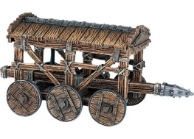

- The Main Gate and Charcoal Burners

- Find the mine entrance; what was the purpose of this?

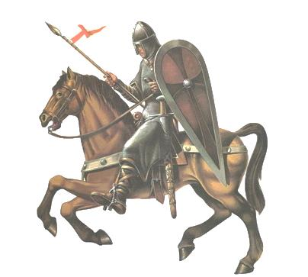
- How was charcoal used and why was it important?

- What was the value to the people of an Eel Pond?

- What story does the ‘plague stone’ tell us about medieval life?

- Why might the gate have been a tough place to attack and capture?

- The Village [In the Bailey by the Gate]

- Find The Stores, what did the Normans do to avoid waste from animals (Green sign).

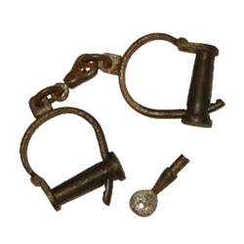
- The Prison; what were some of the punishments that were used and for what crimes?

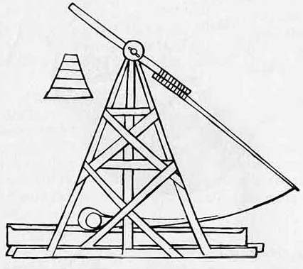
- Have a look at the recreated catapults, what did the Normans call them in the medieval time?

- The Kitchen; what can you recognise here that you find in your own home and what is very different?

- Weaver’s House; briefly describe how wool was turned to cloth.

- The Surgeon’s House; why might having to amputate a limb have been very common and why do you think it was done so quickly?

- The Village [Far Side of the Bailey]

- What was the Hell-Hole used for?

- The Potter’s Hut; why was what the Potter produced so useful?

- The Brewer’s Hut; why was beer and wine so important to people then and how was it made?

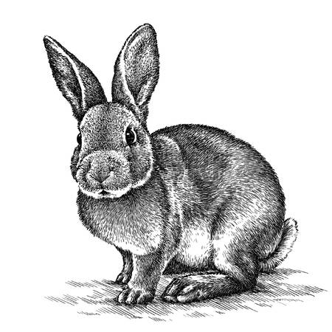
- The Ducking Stool, what was it used for?
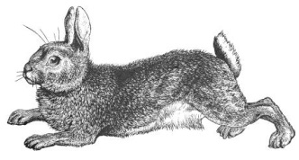

- The Blacksmith; what was made and repaired here?

- The Church; how do we know that this was one of the most important parts of any village?

- Choose at least one other aspect of the village and sketch or describe it, making sure you include how / why it was important.

- The Inner Bailey and Grand Hall

- Why would the inner Bailey have been a tough place to attack?

- What do you think the Grand Hall was used for apart from feasting?

- The Armoury, list some of the weapons you can see and explain which you think would have been the most deadly.

- Upstairs is the Baron’s Bedroom, how does this compare to other parts of the castle you have seen?

- Choose one other aspect of the Inner Bailey to describe and explain. Sketch it if possible.

