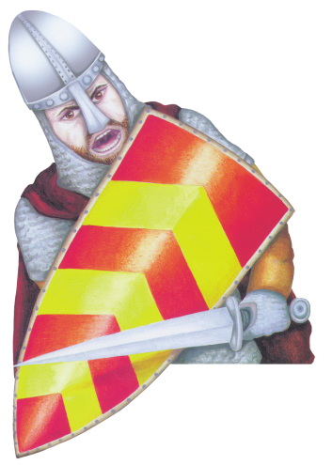
Mountfitchet Castle
& Norman Village of 1066

Fieldtrip activity sheet Key Stage 1

Name: Teacher: Class:

Welcome to Mountfitchet Castle.

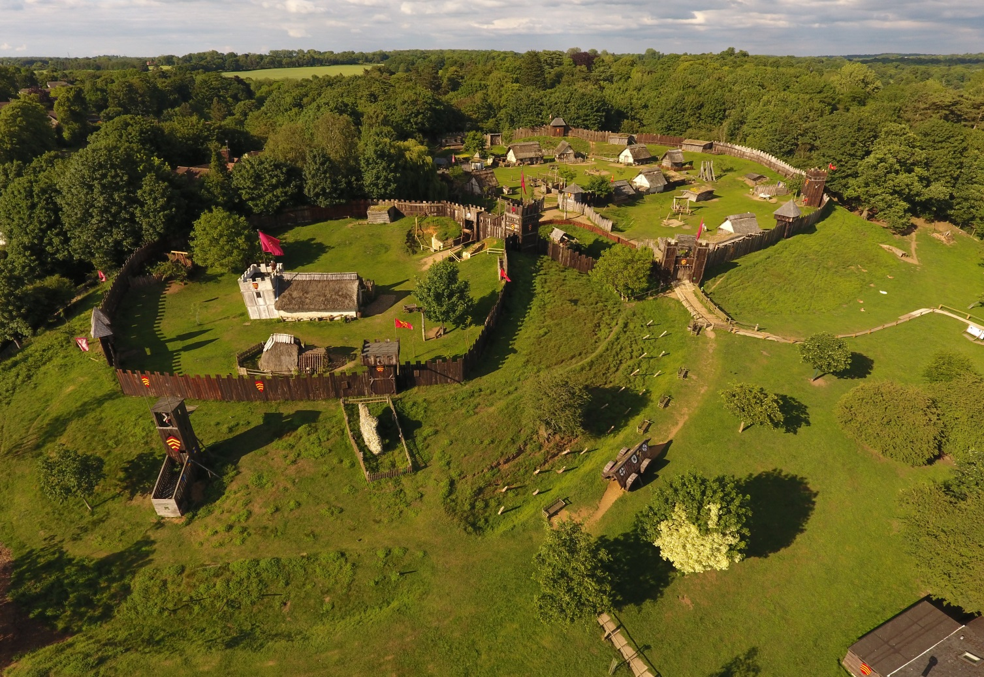

You are entering a castle called a Motte and Bailey Castle. You are going back in time to 900 years ago. Life was very different 900 years ago.

As you walk around the castle you will see many different types of animals. All of them roam freely and trust you so please be kind to them and do not betray their trust.

- How many different animals can you name as you walk around the castle? ________________________________________________________________________________________________________________________

- Draw a picture of your favourite animal in the box below

Why is this your favourite animal?

- Grand Hall. Who lived in the Grand Hall? ____________________________

- Grand Hall. Did the Baron and his lady wear the same clothes as the villagers or did they wear better clothes? _____________________

- Wood was a very important material to the Normans. Based on what you see as you walk around here at Mountfitchet Castle, make a list of the many uses the Normans had for wood: ________________________________________________________________________________________________________________________

- Community House. The community house is one of the family homes for the workers in the castle village. How many families lived in the castle walls? _________________

- Community House. Roughly how many people were in each family, so lived in this community house? __________________

- Community House. How often did people bath in the summer and the winter? ____________________________________________________________

- Community House. What did people cover themselves in to keep warm? ______________

- Alchemist. What did the Alchemist make to help the villagers? _____________________

- Surgeon. What sort of operations did the surgeon do? _____________________

- Surgeon. Why did many of the surgeon’s patients die? ___________________________________________________________

- Prison. What would happen to you if you were caught hunting the Baron’s deer? ____________________________________________________________

- Brew House. There were 2 main types of drinks made in the brew house, what were they? _________________________

Thank you for visiting Mountfitchet Castle.

