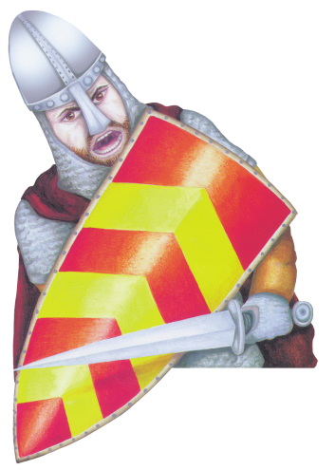
Mountfitchet Castle
& Norman Village of 1066

Fieldtrip activity sheet Key Stage 2

Name: Teacher: Class:

Welcome to Mountfitchet Castle.

Match the following castle key words to their correct meaning:

Castle key word | Word meanings
Motte | Wall made from wood surrounding castle
Bailey | An area enclosed by a wall
Palisade | Strongly protected enclosure at the heart of a medieval castle. It is protected by the outer Bailey. The most important people live here.
Inner Bailey | The defended outer enclosure of the castle. It protects the inner bailey. It contains all the buildings e.g. stores/church needed to supply everyone in the Motte and Bailey castle.
Outer Bailey | A deep wide ditch dug at the bottom of a castle to help protect it, it was often filled with water.
Moat | A member of the English nobility. The king gave land to this person. This person had to provide soldiers for the king, serve on the king's council and provide food and beds to the king and his men when they travelled through the land.
Baron | Mound
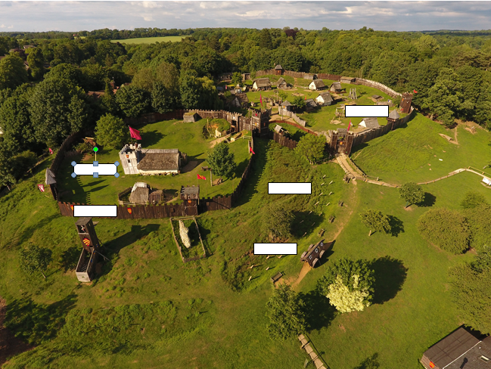
Add the following labels onto the photo of Mountfitchet Castle below: Inner bailey, outer bailey, palisade, moat and motte.

When you enter the Castle and Norman village site you must remember that you have now travelled back in time 900 years. Life was very difficult and uncomfortable, and in most cases, very short. The average life expectancy (age a person lived to) was around 40 years. Why did people not live very long during medieval times? Discuss the answer with your group.

The people who lived here 900 years ago knew nothing about all the modern day comforts and luxuries we have today e.g. central heating. Create a list below of other modern day comforts or luxuries that we have that they would not have known about in medieval times:

- -
- -
- -
- -
Mountfitchet Castle map
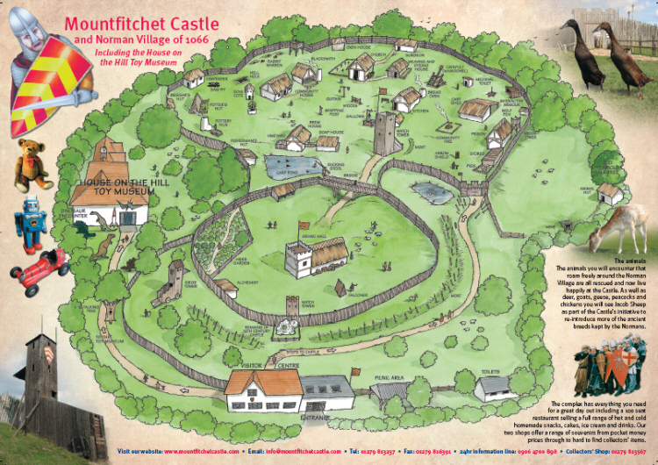

As you walk around the medieval village you will see many different types of animals. All of them roam freely and trust you so please be kind to them and do not betray their trust.

Fieldwork questions:
As you walk around the castle answer the following questions….

- What type of castle is Mountfitchet Castle?________________________

- Main castle gate. Battles and small fights happened often in Norman times and castles such as this one were attacked often. Think about the position the castle was built in. Do you think it was built on a hill to make it difficult for raiders to attack or do you think it was to make it easier to defend, or perhaps both? Explain your answer
________________________________________________________________________________________________________________________

- What do you think the reason was for building the castle close to a river?
__________________________________________________________

- Grand Hall. Who lived in the Grand Hall? ____________________________

- Grand Hall. Robert De Gernon, the Duke of Boulogne, built this castle when he conquered Stansted in what year? _____________________

- Why do you think early Norman castles were made of wood?
___________________________________________________________

- Wood was a very important material to the Normans. Based on what you see as you walk around here at Mountfitchet Castle, make a list of the many uses the Normans had for wood: ______________________________________________________________________________________________________________________

- Church. What was a very important role that the priest had within the castle’s community? ___________________________________________________________

- Community House. The community house is a typical family home in the castle community. How many families lived in the castle walls? _________________

- Community House. Roughly how many people were in each family? Therefore, how many lived in this community house? __________________

- Community House. How often did people bath in the summer and the winter? ____________________________________________________________

- Community House. What did people cover themselves in to keep warm? ______________

- Large chicken house on stilts. Where did chickens originally come from? ___________

- Small chicken house on stilts. Most of the chicken houses were built on stilts, why were they built this way? ___________________________________________________________

- Alchemist. What did the Alchemist make to help the villagers? _____________________

- Surgeon. What sort of operations did the surgeon do? _____________________

- Surgeon. Why did many of the surgeon’s patients die? ___________________________________________________________

- Prison. What would happen to you if you were caught hunting the Baron’s deer? ____________________________________________________________

- Brew House. There were 2 main types of drinks produced, what were they? _________________________

- Why do you think people drank so little water in medieval times? ___________________________________________________________

- Stocks. What sort of crime did someone do to end up being be put in the stocks? ____________________________________

- Stocks. What would happen to the person in the stocks? ____________________________________________________________

- Ducking stool. What was the ducking stool used for? ___________________________________________________________

- Herb garden. Read the herb signs. What was lavender used for? ___________________________________________________________

- Catapult. Sketch the catapult. What was this used for?

- What have you found out today which has surprised you? Why? ____________________________________________________________________________ ________________________________________________________________________________________________________________________________________________________
- If you had a choice, would you rather live as you do today or as a Norman lord or lady in medieval times? Why? ____________________________________________________________________________________________________________________________________________________________________________________

Medieval word match! Old verses New
Medieval word | Current day word
Bodkin | Attack
Destrier | Chemist
Peasant | Candlestick
Sconce | Worker
Infantry | Lavatory
Manacle | Knight Horse
Garderobe | Oven
Garrison | Handcuffs
Sentry | Arrowhead
Alchemist | Army
Kiln | Guard
Siege | Soldiers

Thank you for visiting Mountfitchet Castle.

